**Team Members:**

|  |  |  |
| --- | --- | --- |
| **No** | **NIM** | **Name** |
| 1 | 2602124120 | IDA BAGUS SWAMBARA SUADNYANA |
| 2 | 2602076866 | ALBERTUS GIOVANNI PRASETYO |
| 3 | 2602078146 | DANIEL EBENEZER BUDIHARTO |
| 4 | 2602139362 | I MADE ANANDA MAHATRESNA |

1. **Database Planning**

|  |
| --- |
| *Database* Toko Sembako.  *Database* Toko Sembako digunakan untuk mengatur jenis barang yang ada di toko sembako tersebut, barang yang masuk (pembelian) dan barang yang keluar (penjualan). |

1. **Requirement and Analysis**

* List of Users

|  |  |
| --- | --- |
| **User** | **Description** |
| Pemilik | Pemilik adalah orang yang memiliki Toko Sembako dan mampu mengatur semua tabel. |
| Kasir | Kasir adalah orang yang bekerja di Toko Sembako dan diberi tanggung jawab untuk mengatur pembelian, penjualan, dan penambahan kustomer baru. |

* List of Functionalities

|  |  |
| --- | --- |
| **Functionality** | **Description** |
| Menambahkan Barang | Menambahkan jenis barang baru ketika ada kontrak kerja *supplier* baru. |
| Menambahkan Pembelian | Menambahkan pembelian ketika ada barang yang masuk. |
| Menambahkan Penjualan | Menambahkan penjualan ketika ada barang yang keluar. |
| Melihat Rekap Pembelian Bulanan | Melihat banyaknya barang yang sudah dibeli dalam kurun waktu satu bulan. |
| Melihat Rekap Penjualan Bulanan | Melihat banyaknya barang yang sudah dijual dalam kurun waktu satu bulan. |
| Melihat Rekap Total | Melihat banyaknya pemasukan dan pengeluaran. |
| Menambah Kustomer Baru | Menambahkan kustomer yang baru ketika membeli barang pertama kali di toko. |
| Menambah Supplier Baru | Menambahkan supplier baru ketika menjual barang pertama kali ke toko. |

* Required Data

|  |  |
| --- | --- |
| **Data** | **Description** |
| Nama Barang | Nama dari barang. |
| Satuan | Satuan dari barang berupa Kilogram atau Liter atau Buah. |
| Harga Beli Barang | Untuk mendapat 1 barang, diperlukan berapa rupiah. |
| Harga Jual Barang | Ketika menjual 1 barang, didapatkan berapa rupiah. |
| Stok | Barang yang tersisa di toko. |
| Retur | Banyaknya barang yang dikembalikan ke Supplier dan ditunggu untuk mendapat gantinya. |
| Tanggal Beli | Tanggal yang dicatat ketika ada barang yang dibeli. |
| Tanggal Jual | Tanggal yang dicatat ketika ada barang yang dijual. |
| Tanggal Registrasi Kustomer | Dicatat ketika ada kustomer baru yang terdaftar. |
| Tanggal Registrasi Supplier | Dicatat ketika ada supplier baru yang terdaftar. |
| Kuantitas Beli | Banyaknya barang yang dibeli. |
| Kuantitas Jual | Banyaknya barang yang dijual. |
| Total Beli | Didapatkan dari harga beli dikali kuantitas. |
| Total Jual | Didapatkan dari harga jual dikali kuantitas. |
| Nama Kustomer | Toko Sembako menjual barang ke Kustomer. |
| Nama Supplier | Toko Sembako membeli barang dari Supplier |

* Mapping of Functionality and User

|  |  |
| --- | --- |
| **Functionality** | **Users** |
| Menambahkan Barang | Pemilik, Kasir |
| Menambahkan Pembelian | Pemilik, Kasir |
| Menambahkan Penjualan | Pemilik, Kasir |
| Melihat Rekap Pembelian Bulanan | Pemilik |
| Melihat Rekap Penjualan Bulanan | Pemilik |
| Melihat Rekap Total | Pemilik |
| Menambah Kustomer Baru | Pemilik, Kasir |
| Menambah Supplier Baru | Pemilik, Kasir |

* Mapping of Data and User

|  |  |
| --- | --- |
| **Data** | **Users** |
| Nama Barang | Pemilik, Kasir |
| Satuan | Pemilik |
| Harga Beli Barang | Pemilik, Kasir |
| Harga Jual Barang | Pemilik, Kasir |
| Stok | Pemilik, Kasir |
| Retur | Pemilik, Kasir |
| Tanggal Beli | Pemilik, Kasir |
| Tanggal Jual | Pemilik, Kasir |
| Tanggal Registrasi Kustomer | Pemilik, Kasir |
| Tanggal Registrasi Supplier | Pemilik, Kasir |
| Kuantitas Beli | Pemilik, Kasir |
| Kuantitas Jual | Pemilik, Kasir |
| Total Beli | Pemilik, Kasir |
| Total Jual | Pemilik, Kasir |
| Nama Kustomer | Pemilik, Kasir |
| Nama Supplier | Pemilik, Kasir |

1. **Database Model**
2. **Conceptual Model**

* List of Entities

|  |  |
| --- | --- |
| **Entity Name** | **Description** |
| bar | Entitas dari barang mencakup nama, satuan, dll. |
| buku_beli | Entitas dari pembelian yang dilakukan Toko Sembako dari supplier mencakup tanggal beli, supplier, barang yang dibeli, dll. |
| buku_jual | Entitas dari penjualan yang dilakukan Toko Sembako ke kustomer mencakup tanggal jual, kustomer, barang yang dijual, dll. |
| cust | Entitas dari kustomer yang melakukan penjualan dari *point of view* Toko Sembako. |
| supp | Entitas dari supplier yang melakukan pembelian dari *point of view* Toko Sembako. |

* Relationships

|  |  |  |  |  |
| --- | --- | --- | --- | --- |
| **Entity Name** | **Cardinality** | **Relationship Name** | **Participant** | **Entity Name** |
| bar | many-to-many | dikurangi | partial | cust |
| bar | many-to-many | ditambah | total | supp |
| buku_beli | one-to-many | barang_masuk | partial | supp |
| buku_jual | one-to-many | barang_keluar | total | cust |
| buku_beli | many-to-one | produk_beli | total | bar |
| buku_jual | many-to-one | produk_jual | total | bar |

* List of Attributes

Entity Name: bar

|  |  |  |  |  |  |
| --- | --- | --- | --- | --- | --- |
| **Attribute** | **Description** | **Type** | **Length** | **Multi Value [Y, N]** | **Null [Y, N]** |
| kode_bar | Mulai dari C001, C002, C003, dst. Primary Key. | CHAR | 4 | N | N |
| nama_bar | Nama dari suatu barang. | VARCHAR | 100 | N | N |
| satuan | Terdiri dari kg, L, bungkus, dan buah. | ENUM | - | N | N |
| hrg_beli | Berapa rupiah yang harus dikeluarkan untuk mendapat barang itu dari supplier. | INT | - | N | N |
| hrg_jual | Berapa rupiah yang didapat ketika barang diberikan ke customer. Selalu bernilai 1,3x harga beli. | INT | - | N | N |
| stok | jumlah barang yang ada di toko sekarang | INT | - | N | N |
| retur | jumlah barang yang dikembalikan kepada supplier | INT | - | N | N |

Entity Name: buku_beli

|  |  |  |  |  |  |
| --- | --- | --- | --- | --- | --- |
| **Attribute** | **Description** | **Type** | **Length** | **Multi Value [Y, N]** | **Null [Y, N]** |
| kode_beli | Mulai dari S001, S002, S003, dst. Primary Key. | CHAR | 4 | N | N |
| tgl_beli | Tanggal pembelian dilakukan. | DATE | - | N | N |
| k_supp | Kode supplier yang memasok. Foreign Key. | CHAR | 4 | N | N |
| k_bar | Kode barang yang dibeli. Foreign Key. Primary Key. | CHAR | 4 | N | N |
| qty_b | Banyaknya barang yang dibeli. | INT | - | N | N |
| total_b | Hasil kali dari qty_b dengan harga_beli di tabel bar. | INT | - | N | N |
| retur | Banyaknya barang yang diretur. | INT | - | N | N |

Entity Name: buku_jual

|  |  |  |  |  |  |
| --- | --- | --- | --- | --- | --- |
| **Attribute** | **Description** | **Type** | **Length** | **Multi Value [Y, N]** | **Null [Y, N]** |
| kode_jual | Mulai dari J001, J002, J003, dst. | CHAR | 4 | N | N |
| tgl_j | Tanggal penjualan dilakukan | DATE | - | N | N |
| k_cust | Kode kustomer yang membeli barang. Foreign Key. Primary Key. | CHAR | 4 | N | N |
| k_bar | Kode barang yang dijual. Foreign Key. Primary Key. | CHAR | 4 | N | N |
| qty_j | Banyaknya barang yang dijual. | INT | - | N | N |
| total_j | Hasil kali dari qty_j dengan harga_jual di tabel bar. | INT | - | N | N |
| hutang | Berapa rupiah customer ini melakukan hutang untuk transaksi ini. | INT | - | N | N |

Entity Name: cust

|  |  |  |  |  |  |
| --- | --- | --- | --- | --- | --- |
| **Attribute** | **Description** | **Type** | **Length** | **Multi Value [Y, N]** | **Null [Y, N]** |
| kode_cust | Dimulai dari K001, K002, K003, dst. Primary Key. | CHAR | 4 | N | N |
| nama_cust | Nama dari customer yang melakukan pembelian. | VARCHAR | 100 | N | N |
| tg_reg_cust | Tanggal customer pertama kali melakukan pembelian. | DATE | - | N | N |
| hutang | Berapa rupiah hutang kustomer. | INT | - | N | N |

Entity Name: supp

|  |  |  |  |  |  |
| --- | --- | --- | --- | --- | --- |
| **Attribute** | **Description** | **Type** | **Length** | **Multi Value [Y, N]** | **Null [Y, N]** |
| kode_supp | Dimulai dari P001, P002, P003, dst. Primary Key. | CHAR | 4 | N | N |
| nama_supp | Nama dari supplier yang melakukan pemasokan. | VARCHAR | 100 | N | N |
| tg_reg_supp | Tanggal supplier pertama kali melakukan pemasokan. | DATE | - | N | N |

* List of Constraints
  1. form_k_bar: kode_bar dimulai dengan C lalu diikuti dengan 3 digit angka yang dimulai dari 001, 002, dst.
  2. form_k_beli: kode_beli dimulai dengan S lalu diikuti dengan 3 digit angka yang dimulai dari 001, 002, dst.
  3. form_k_jual: kode_jual dimulai dengan J lalu diikusi dengan 3 digit angka yang dimulai dari 001, 002, dst.
  4. form_k_cust: kode_cust dimulai dengan K lalu diikuti dengan 3 digit angka yang dimulai dari 001, 002, dst.
  5. form_k_supp: kode_supp dimulai dengan P lalu diikuti dengan 3 digit angka yang dimulai dari 001, 002, dst.
  6. sl_untung: hrg_jual selalu bernilai 1,3x hrg_beli.
  7. const_sat_enum: satuan hanya bisa antara kg, atau L, atau bungkus, atau buah.
  8. max_retur: retur tidak boleh lebih dari 15.

1. **Logical Model**

* Functional Dependency

**Tabel bar**  
kode_bar -> nama_bar, satuan, hrg_beli, hrg_jual, stok, retur

**Tabel buku_beli**

kode_beli, k_bar -> tgl_b, k_supp, qty_b, total_b, retur

**Tabel buku_jual**  
kode_jual, k_bar-> tgl_j, k_cust, qty_j, total_j, hutang

**Tabel cust**

kode_cust -> nama_cust, tg_reg_cust, hutang

**Tabel supp**

kode_supp -> nama_supp, tg_reg_supp

* UNF

Tabel Pembelian

|  |  |  |  |  |  |  |  |  |  |  |  |  |
| --- | --- | --- | --- | --- | --- | --- | --- | --- | --- | --- | --- | --- |
| kode_bar | nama_bar | satuan | hrg_beli | stok | retur | kode_beli | tgl_b | k_supp | nama_supp | tg_reg_supp | qty_b | total_b |
| C001 | Beras Premium | kg | 11000 | 100 | 0 | S001 | 2023-06-01 | P001 | Supplier Beras | 2023-01-01 | 10 | 143000 |
| C002 | Gula Pasir | kg | 12000 | 80 | 0 | S002 | 2023-06-02 | P002 | Supplier Gula | 2023-01-02 | 15 | 234000 |
| C003 | Minyak Goreng | L | 14000 | 150 | 0 | S003 | 2023-06-03 | P003 | Supplier Minya | 2023-01-03 | 20 | 364000 |
| C004 | Mie Instan | bungkus | 2200 | 200 | 0 | S004 | 2023-006-04 | P004 | Supplier Mie | 2023-01-04 | 25 | 71500 |
| C005 | Telur Ayam | buah | 2000 | 200 | 0 | S005 | 2023-06-05 | P005 | Supplier Telur | 2023-01-05 | 30 | 7800 |

Tabel Penjualan

|  |  |  |  |  |  |  |  |  |  |  |  |  |
| --- | --- | --- | --- | --- | --- | --- | --- | --- | --- | --- | --- | --- |
| kode_bar | nama_bar | satuan | hrg_jual | stok | kode_jual | tgl_j | k_cust | nama_cust | tg_reg_cust | hutang | qty_j | total_j |
| C001 | Beras Premium | kg | 14300 | 100 | J001 | 2023-06-10 | K001 | Andi Setiawan | 2023-01-01 | 0 | 5 | 71500 |
| C002 | Gula Pasir | kg | 15600 | 80 | J002 | 2023-06-11 | K002 | Rina Kumala | 2023-01-02 | 0 | 10 | 156000 |
| C003 | Minyak goreng | L | 18200 | 150 | J003 | 2023-06-12 | K003 | Budi Santoso | 2023-01-03 | 0 | 8 | 145600 |
| C004 | Mie Instan | bungkus | 2860 | 200 | J004 | 2023-06-13 | K004 | Siri Nurhaliza | 2023-01-04 | 0 | 20 | 57200 |
| C005 | Terlu Ayam | buah | 2600 | 200 | J005 | 2023-06-14 | K005 | Dewi Ayu | 2023-01-05 | 0 | 50 | 130000 |

* 1NF

Tabel Pembelian

|  |  |  |  |  |  |  |  |  |  |  |  |  |
| --- | --- | --- | --- | --- | --- | --- | --- | --- | --- | --- | --- | --- |
| kode_bar | nama_bar | satuan | hrg_beli | stok | retur | kode_beli | tgl_b | k_supp | nama_supp | tg_reg_supp | qty_b | total_b |
| C001 | Beras Premium | kg | 11000 | 100 | 0 | S001 | 2023-06-01 | P001 | Supplier Beras | 2023-01-01 | 10 | 143000 |
| C002 | Gula Pasir | kg | 12000 | 80 | 0 | S002 | 2023-06-02 | P002 | Supplier Gula | 2023-01-02 | 15 | 234000 |
| C003 | Minyak Goreng | L | 14000 | 150 | 0 | S003 | 2023-06-03 | P003 | Supplier Minya | 2023-01-03 | 20 | 364000 |
| C004 | Mie Instan | bungkus | 2200 | 200 | 0 | S004 | 2023-006-04 | P004 | Supplier Mie | 2023-01-04 | 25 | 71500 |

Tabel Penjualan

|  |  |  |  |  |  |  |  |  |  |  |  |  |
| --- | --- | --- | --- | --- | --- | --- | --- | --- | --- | --- | --- | --- |
| kode_bar | nama_bar | satuan | hrg_jual | stok | kode_jual | tgl_j | k_cust | nama_cust | tg_reg_cust | hutang | qty_j | total_j |
| C001 | Beras Premium | kg | 14300 | 100 | J001 | 2023-06-10 | K001 | Andi Setiawan | 2023-01-01 | 0 | 5 | 71500 |
| C002 | Gula Pasir | kg | 15600 | 80 | J002 | 2023-06-11 | K002 | Rina Kumala | 2023-01-02 | 0 | 10 | 156000 |
| C003 | Minyak goreng | L | 18200 | 150 | J003 | 2023-06-12 | K003 | Budi Santoso | 2023-01-03 | 0 | 8 | 145600 |
| C004 | Mie Instan | bungkus | 2860 | 200 | J004 | 2023-06-13 | K004 | Siri Nurhaliza | 2023-01-04 | 0 | 20 | 57200 |
| C005 | Terlu Ayam | buah | 2600 | 200 | J005 | 2023-06-14 | K005 | Dewi Ayu | 2023-01-05 | 0 | 50 | 130000 |

* 2NF

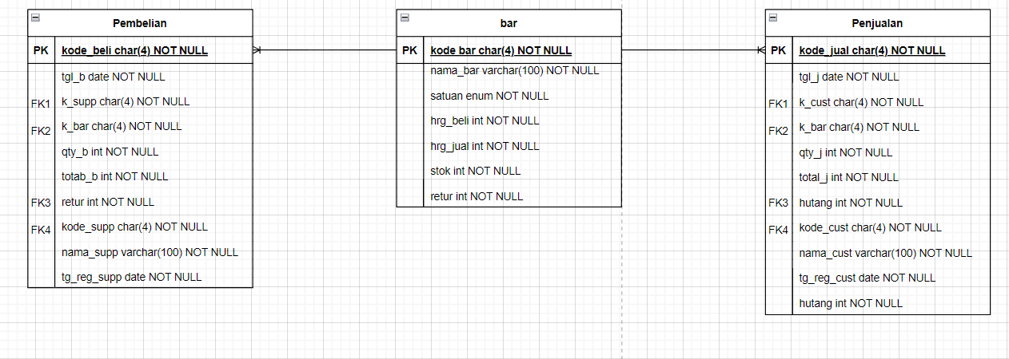

Tabel barang

|  |  |  |  |  |  |  |
| --- | --- | --- | --- | --- | --- | --- |
| kode_bar | nama_bar | satuan | hrg_beli | hrg_jual | stok | retur |
| C001 | Beras Premium | kg | 11000 | 14300 | 100 | 0 |
| C002 | Gula Pasir | kg | 12000 | 15600 | 80 | 0 |
| C003 | Minyak Goreng | L | 14000 | 18200 | 150 | 0 |
| C004 | Mie Instan | bungkus | 2200 | 2860 | 200 | 0 |
| C005 | Telur Ayam | buah | 2000 | 2600 | 200 | 0 |

Tabel Pembelian

|  |  |  |  |  |  |  |  |  |
| --- | --- | --- | --- | --- | --- | --- | --- | --- |
| kode_beli | tgl_b | k_supp | k_bar | qty_b | total_b | retur | nama_supp | tg_reg_supp |
| S001 | 2023-06-01 | P001 | C001 | 10 | 143000 | 0 | Supplier Beras | 2023-06-01 |
| S002 | 2023-06-02 | P002 | C002 | 15 | 234000 | 0 | Supplier Gula | 2023-06-02 |
| S003 | 2023-06-03 | P003 | C003 | 20 | 360000 | 0 | Supplier Minyak | 2023-06-13 |
| S004 | 2023-06-04 | P004 | C004 | 25 | 71500 | 0 | Supplier Mie | 2023-06-04 |
| S005 | 2023-06-05 | P005 | C005 | 30 | 78000 | 0 | Supplier Telur | 2023-06-05 |

Tabel Penjualan

|  |  |  |  |  |  |  |  |  |
| --- | --- | --- | --- | --- | --- | --- | --- | --- |
| kode_jual | tgl_j | k_cust | k_bar | qty_j | total_j | nama_cust | tg_reg_cust | hutang |
| J001 | 2023-06-10 | K001 | C001 | 5 | 71500 | Andi Setiawan | 2023-01-01 | 0 |
| J002 | 2023-06-11 | K002 | C002 | 10 | 156000 | Rina Kumala | 2023-02-01 | 0 |
| J003 | 2023-06-12 | K003 | C003 | 8 | 145600 | Budi Santoso | 2023-03-01 | 0 |
| J004 | 2023-06-13 | K004 | C004 | 20 | 57200 | Siti Nurhaliza | 2023-04-01 | 0 |
| J005 | 2023-06-14 | K005 | C005 | 50 | 130000 | Dewi Ayu | 2023-05-01 | 0 |

* 3NF

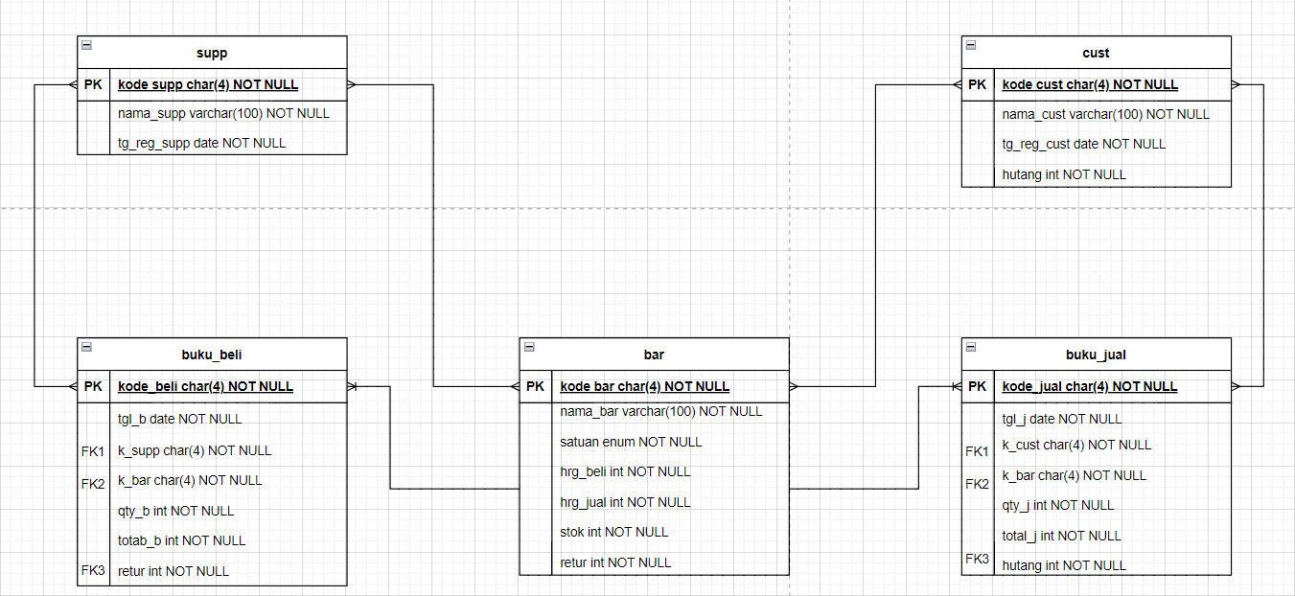

Tabel Barang

|  |  |  |  |  |  |  |
| --- | --- | --- | --- | --- | --- | --- |
| kode_bar | nama_bar | satuan | hrg_beli | hrg_jual | stok | retur |
| C001 | Beras Premium | KG | 11.000 | 14.300 | 100 | 0 |
| C002 | Gula Pasir | KG | 12.000 | 15.600 | 80 | 0 |
| C003 | Minyak Goreng | L | 14.000 | 18.200 | 150 | 0 |
| C004 | Mie Instan | Bungkus | 2200 | 2860 | 200 | 0 |
| C005 | Telur Ayam | Buah | 2000 | 2600 | 200 | 0 |

Tabel Buku Beli

|  |  |  |  |  |  |  |
| --- | --- | --- | --- | --- | --- | --- |
| kode_beli | tgl_b | k_supp | k_bar | qty_b | total_b | retur |
| S001 | 2023-06-01 | P001 | C001 | 10 | 143.000 | 0 |
| S002 | 2023-06-02 | P002 | C002 | 15 | 234.000 | 0 |
| S003 | 2023-06-03 | P003 | C003 | 20 | 364.000 | 0 |
| S004 | 2023-06-04 | P004 | C004 | 25 | 71.500 | 0 |
| S005 | 2023-06-05 | P005 | C005 | 30 | 78.000 | 0 |

Tabel Buku Jual

|  |  |  |  |  |  |  |
| --- | --- | --- | --- | --- | --- | --- |
| kode_jual | tgl_j | k_cust | k_bar | qty_j | total_j | hutang |
| J001 | 2023-06-10 | K001 | C001 | 5 | 71.500 | 0 |
| J002 | 2023-06-11 | K002 | C002 | 10 | 156.000 | 0 |
| J003 | 2023-06-12 | K003 | C003 | 8 | 145.600 | 0 |
| J004 | 2023-06-13 | K004 | C004 | 20 | 57.200 | 0 |
| J005 | 2023-06-14 | K005 | C005 | 50 | 130.000 | 0 |

Tabel Supplier

|  |  |  |
| --- | --- | --- |
| kode_supp | nama_supp | tg_reg_supp |
| P001 | Supplier Beras | 2023-01-01 |
| P002 | Supplier Gula | 2023-01-02 |
| P003 | Supplier Minyak | 2023-01-03 |
| P004 | Supplier Mie | 2023-01-04 |
| P005 | Supplier Telor | 2023-01-05 |

Tabel Customer

|  |  |  |  |
| --- | --- | --- | --- |
| kode_cust | nama_cust | tg_reg_cust | hutang |
| K001 | Andi Setiawan | 2023-01-01 | 0 |
| K002 | Rina Kumala | 2023-02-01 | 0 |
| K003 | Budi Santoso | 2023-03-01 | 0 |
| K004 | Siti Nurhaliza | 2023-04-01 | 0 |
| K005 | Dewi Ayu | 2023-05-01 | 0 |

* BCNF

<BCNF analysis and result through ERD model>

1. **Physical Model**

* View

bar_now()

htg_cust()

bar_retur()

bar_retur_supp()

* Stored Procedure

add_new_bar(nama_bar, satuan, hrg_beli)

rkp_beli_bln_x(bulan x)  
rkp_jual_bln_x(bulan x)

rkp_total_bln_x(bulan x)

beli_br_y_retur(k_supp, k_bar, hrg_beli, qty_b, retur)

beli_br_n_retur(k_supp, k_bar, hrg_beli, qty_b)

jual_br_y_htg(kode_cust, kode_bar, qty_jual, jml_brg_htg)

jual_br_n_htg(kode_cust, kode_bar, qty_jual)

1. **Appendix**

- Queries  
<https://docs.google.com/document/d/1iItaGTZuXH_GLURVOwwxy3Sz18Ijm33Eg3R8PzUJ0e4/edit?usp=sharing>   
CREATE TABLE bar(

kode_bar CHAR(4) NOT NULL PRIMARY KEY CHECK (kode_bar REGEXP '^C[0-9][0-9][0-9]$'),

nama_bar VARCHAR(100) NOT NULL,

satuan ENUM('kg', 'L', 'bungkus', 'buah') NOT NULL,

harga_beli INT NOT NULL,

harga_jual INT NOT NULL DEFAULT (harga_beli * 1.3),

stok INT NOT NULL,

retur INT NOT NULL CHECK (retur <= 15)

);

CREATE TABLE supp(

kode_supp CHAR(4) NOT NULL PRIMARY KEY CHECK (kode_supp REGEXP '^P[0-9][0-9][0-9]$'),

nama_supp VARCHAR(100) NOT NULL,

tg_reg_supp DATE NOT NULL

);

CREATE TABLE cust(

kode_cust CHAR(4) NOT NULL PRIMARY KEY CHECK (kode_cust REGEXP '^K[0-9][0-9][0-9]$'),

nama_cust VARCHAR(100) NOT NULL,

tg_reg_cust DATE NOT NULL,

hutang INT NOT NULL CHECK (hutang<=450000)

);

4. CREATE TABLE buku_beli(

kode_beli CHAR(4) NOT NULL CHECK (kode_beli REGEXP '^S[0-9][0-9][0-9]$'),

tgl_b DATE NOT NULL,

k_supp CHAR(4) NOT NULL,

FOREIGN KEY(k_supp) REFERENCES supp(kode_supp)

ON UPDATE CASCADE

ON DELETE CASCADE,

k_bar CHAR(4) NOT NULL,

FOREIGN KEY(k_bar) REFERENCES bar(kode_bar)

ON UPDATE CASCADE

ON DELETE CASCADE,

PRIMARY KEY(kode_beli, k_bar),

qty_b INT NOT NULL,

total_b INT NOT NULL,

retur INT NOT NULL

);

CREATE TABLE buku_jual(

kode_jual CHAR(4) NOT NULL CHECK (kode_jual REGEXP '^J[0-9][0-9][0-9]$'),

tgl_j DATE NOT NULL,

k_cust CHAR(4) NOT NULL,

FOREIGN KEY(k_cust) REFERENCES cust(kode_cust)

ON UPDATE CASCADE

ON DELETE CASCADE,

k_bar CHAR(4) NOT NULL,

FOREIGN KEY(k_barang) REFERENCES bar(kode_bar)

ON UPDATE CASCADE

ON DELETE CASCADE,

PRIMARY KEY(kode_jual, k_barang),

qty_j INT NOT NULL,

total_j INT NOT NULL,

hutang INT NOT NULL

);

INSERT INTO bar (kode_bar, nama_bar, satuan, harga_beli, harga_jual, stok, retur)

VALUES

('C001', 'Beras Premium', 'kg', 11000, 14300, 100, 0),

('C002', 'Gula Pasir', 'kg', 12000, 15600, 80, 0),

('C003', 'Minyak Goreng', 'L', 14000, 18200, 150, 0),

('C004', 'Mie Instan', 'bungkus', 2200, 2860, 200, 0),

('C005', 'Telur Ayam', 'buah', 2000, 2600, 200, 0);

INSERT INTO supp (kode_supp, nama_supp, tg_reg_supp)

VALUES

('P001', 'Supplier Beras', '2023-01-01'),

('P002', 'Supplier Gula', '2023-01-02'),

('P003', 'Supplier Minyak', '2023-01-03'),

('P004', 'Supplier Mie', '2023-01-04'),

('P005', 'Supplier Telur', '2023-01-05');

INSERT INTO cust (kode_cust, nama_cust, tg_reg_cust, hutang)

VALUES

('K001', 'Andi Setiawan', '2023-01-01', 0),

('K002', 'Rina Kumala', '2023-02-01', 0),

('K003', 'Budi Santoso', '2023-03-01', 0),

('K004', 'Siti Nurhaliza', '2023-04-01', 0),

('K005', 'Dewi Ayu', '2023-05-01', 0);

INSERT INTO buku_beli (kode_beli, tgl_beli, k_supp, k_barang, qty_barang, total_barang, retur)

VALUES

('S001', '2023-06-01', 'P001', 'C001', 10, 143000, 0),

('S002', '2023-06-02', 'P002', 'C002', 15, 234000, 0),

('S003', '2023-06-03', 'P003', 'C003', 20, 364000, 0),

('S004', '2023-06-04', 'P004', 'C004', 25, 71500, 0),

('S005', '2023-06-05', 'P005', 'C005', 30, 78000, 0);

INSERT INTO buku_jual (kode_jual, tgl_jual, k_cust, k_barang, qty_jual, total_jual, hutang)

VALUES

('J001', '2023-06-10', 'K001', 'C001', 5, 71500, 0),

('J002', '2023-06-11', 'K002', 'C002', 10, 156000, 0),

('J003', '2023-06-12', 'K003', 'C003', 8, 145600, 0),

('J004', '2023-06-13', 'K004', 'C004', 20, 57200, 0),

('J005', '2023-06-14', 'K005', 'C005', 50, 130000, 0);

CREATE VIEW bar_now AS

SELECT kode_bar AS 'Kode Barang',

nama_bar as 'Nama Barang',

satuan as 'Satuan',

harga_beli AS 'Harga Beli',

harga_jual AS 'Harga Jual',

stok as 'Stok',

retur as 'Retur'

from bar;

create view htg_cust AS

select kode_cust as 'Kode Kustomer',

nama_cust as 'Nama Kustomer',

tg_reg_cust as 'Tanggal Registrasi Kustomer',

hutang as 'Hutang'

from cust

where hutang > 0;

create view bar_retur AS

select kode_bar as 'Kode Barang',

nama_bar as 'Nama Barang',

stok as 'Stok',

retur as 'Retur'

from bar

where retur > 0;

create view bar_retur_supp AS

select bb.kode_beli as 'Kode Beli',

bb.tgl_b AS 'Tanggal Beli',

bb.k_supp as 'Kode Supplier',

bb.k_bar AS 'Kode Barang',

bb.retur AS 'Jumlah Retur'

from buku_beli AS bb

JOIN supp AS s ON s.kode_supp = bb.k_supp

JOIN bar as b on b.kode_bar = bb.k_bar

where bb.retur > 0

GROUP BY bb.kode_beli, bb.k_bar, bb.k_supp

ORDER BY bb.tgl_b ASC;

DELIMITER //

CREATE PROCEDURE add_new_bar(IN nama_bar VARCHAR(100), IN satuan ENUM('kg','L','bungkus','buah'), IN hrg_beli INT)

BEGIN

DECLARE new_kode_bar CHAR(4);

DECLARE max_kode_bar INT;

SELECT CONVERT(SUBSTRING(MAX(kode_bar), 2, 3), INT) + 1 INTO max_kode_bar FROM bar;

IF ISNULL(max_kode_bar) THEN

SET new_kode_bar = 'C001';

ELSE

SET new_kode_bar = CONCAT('C', LPAD(max_kode_bar, 3, '0'));

END IF;

INSERT INTO bar (kode_bar, nama_bar, satuan, harga_beli, harga_jual, stok, retur) VALUES (new_kode_bar, nama_bar, satuan, hrg_beli, hrg_beli * 1.3, 0, 0);

END //

DELIMITER ;

call add_new_bar('Tepung Terigu', 'kg', 10000);

DELIMITER //

CREATE PROCEDURE beli_br_y_retur(

IN k_supp CHAR(4),

IN k_bar CHAR(4),

IN hrg_beli INT,

IN qty_b INT,

IN retur INT

)

BEGIN

DECLARE max_kode_beli INT;

DECLARE new_kode_beli CHAR(4);

SELECT CONVERT(SUBSTRING(MAX(kode_beli), 2, 3), INT) + 1 INTO max_kode_beli FROM buku_beli;

IF ISNULL(max_kode_beli) THEN

SET new_kode_beli = 'S001';

ELSE

SET new_kode_beli = CONCAT('S', LPAD(max_kode_beli, 3, '0')); -- With comma here

END IF;

UPDATE bar br

SET br.harga_beli = hrg_beli, br.harga_jual = hrg_beli * 1.3, br.retur = br.retur + retur, br.stok = br.stok + (qty_b - retur)

WHERE br.kode_bar = k_bar;

INSERT INTO buku_beli (kode_beli, tgl_b, k_supp, k_bar, qty_b, total_b, retur)

VALUES (new_kode_beli, CURRENT_DATE, k_supp, k_bar, qty_b, hrg_beli * qty_b, retur);

END //

DELIMITER ;

CALL beli_br_y_retur('P004', 'C004', 2300, 15, 5);

CALL beli_br_y_retur('P004', 'C004', 2300, 15, 5);

DELIMITER //

CREATE PROCEDURE beli_br_n_retur(

IN k_supp CHAR(4),

IN k_bar CHAR(4),

IN hrg_beli INT,

IN qty_b INT

)

BEGIN

DECLARE max_kode_beli INT;

DECLARE new_kode_beli CHAR(4);

DECLARE total_cost DECIMAL(10,2); -- Add variable for total cost

SELECT CONVERT(SUBSTRING(MAX(kode_beli), 2, 3), INT) + 1 INTO max_kode_beli FROM buku_beli;

IF ISNULL(max_kode_beli) THEN

SET new_kode_beli = 'S001';

ELSE

SET new_kode_beli = CONCAT('S', LPAD(max_kode_beli, 3, '0'));

END IF;

SET total_cost = hrg_beli * qty_b; -- Calculate total cost once

UPDATE bar br

SET br.harga_beli = hrg_beli, br.harga_jual = hrg_beli * 1.3, br.stok = br.stok + qty_b

WHERE br.kode_bar = k_bar;

INSERT INTO buku_beli (kode_beli, tgl_b, k_supp, k_bar, qty_b, total_b, retur)

VALUES (new_kode_beli, CURRENT_DATE, k_supp, k_bar, qty_b, total_cost, 0);

END //

DELIMITER ;

DELIMITER //

CREATE PROCEDURE jual_br_y_htg(

IN kode_cust CHAR(4),

IN kode_bar CHAR(4),

IN qty_jual INT,

IN jml_brg_htg INT

)

BEGIN

DECLARE max_kode_jual INT;

DECLARE new_kode_jual CHAR(4);

DECLARE harga_jual INT;

SELECT CONVERT(SUBSTRING(MAX(kode_jual), 2, 3), SIGNED) + 1 INTO max_kode_jual FROM buku_jual;

SELECT br.harga_jual INTO harga_jual

FROM bar br

WHERE br.kode_bar = kode_bar;

IF max_kode_jual IS NULL THEN

SET new_kode_jual = 'J001';

ELSE

SET new_kode_jual = CONCAT('J', LPAD(max_kode_jual, 3, '0'));

END IF;

UPDATE bar br

SET br.stok = br.stok - qty_jual

WHERE br.kode_bar = kode_bar;

UPDATE cust cs

SET cs.hutang = cs.hutang + jml_brg_htg * harga_jual

WHERE cs.kode_cust = kode_cust;

INSERT INTO buku_jual (kode_jual, tgl_j, k_cust, k_bar, qty_j, total_j, hutang)

VALUES (new_kode_jual, CURRENT_DATE, kode_cust, kode_bar, qty_jual, qty_jual * harga_jual, jml_brg_htg * harga_jual);

END //

DELIMITER ;

DELIMITER //

CREATE PROCEDURE jual_br_n_htg(

IN kode_cust CHAR(4),

IN kode_bar CHAR(4),

IN qty_jual INT

)

BEGIN

DECLARE max_kode_jual INT;

DECLARE new_kode_jual CHAR(4);

DECLARE harga_jual INT;

SELECT CONVERT(SUBSTRING(MAX(kode_jual), 2, 3), INT) + 1 INTO max_kode_jual FROM buku_jual;

SELECT br.harga_jual INTO harga_jual

FROM bar br

WHERE br.kode_bar = kode_bar;

IF ISNULL(max_kode_jual) THEN

SET new_kode_jual = 'J001';

ELSE

SET new_kode_jual = CONCAT('J', LPAD(max_kode_jual, 3, '0'));

END IF;

UPDATE bar br

SET br.stok = br.stok - qty_jual

WHERE br.kode_bar = kode_bar;

INSERT INTO buku_jual (kode_jual, tgl_j, k_cust, k_bar, qty_j, total_j, hutang)

VALUES (new_kode_jual, CURRENT_DATE, kode_cust, kode_bar, qty_jual, qty_jual * harga_jual, 0);

END //

DELIMITER ;

DELIMITER //

CREATE PROCEDURE rekap_beli_bulanan(IN bulan INT)

BEGIN

SELECT bb.kode_beli, bb.tgl_b, bb.qty_b, bb.total_b, s.nama_supp, b.nama_bar

FROM buku_beli AS bb

JOIN supp AS s ON bb.k_supp = s.kode_supp

JOIN bar AS b ON bb.k_bar = b.kode_bar

WHERE MONTH(bb.tgl_b) = bulan;

END //

DELIMITER ;

DELIMITER //

CREATE PROCEDURE rekap_jual_bulanan(IN bulan INT)

BEGIN

SELECT

MONTH(bj.tgl_j) AS Bulan,

YEAR(bj.tgl_j) AS Tahun,

b.nama_bar AS Nama_Barang,

SUM(bj.qty_j) AS Jumlah_Penjualan,

SUM(bj.total_j) AS Total_Penjualan

FROM

buku_jual AS bj

JOIN

bar AS b ON bj.k_bar = b.kode_bar

WHERE

MONTH(bj.tgl_j) = bulan

GROUP BY

MONTH(bj.tgl_j), bj.k_bar;

END //

DELIMITER ;

DELIMITER //

CREATE PROCEDURE rekap_total(IN bulan INT)

BEGIN

DECLARE tgl_awal DATE;

DECLARE tgl_akhir DATE;

SET tgl_awal = CONCAT(YEAR(CURDATE()), '-', LPAD(bulan, 2, '0'), '-01');

SET tgl_akhir = LAST_DAY(tgl_awal);

SELECT

SUM(CASE WHEN MONTH(bb.tgl_b) = bulan THEN bb.total_b ELSE 0 END) AS total_pembelian,

SUM(CASE WHEN MONTH(bj.tgl_j) = bulan THEN bj.total_j ELSE 0 END) AS total_penjualan

FROM

buku_beli AS bb

JOIN buku_jual AS bj ON bb.k_bar = bj.k_bar

WHERE

MONTH(bb.tgl_b) = bulan OR MONTH(bj.tgl_j) = bulan;

END //

DELIMITER ;

- Result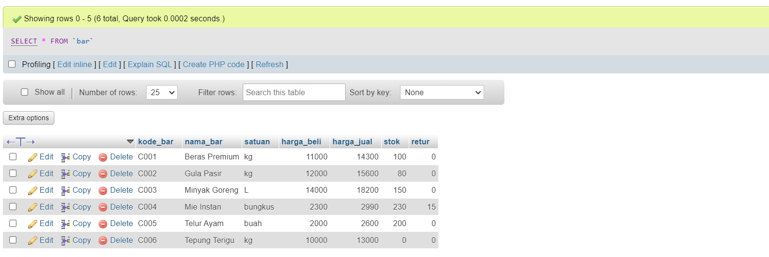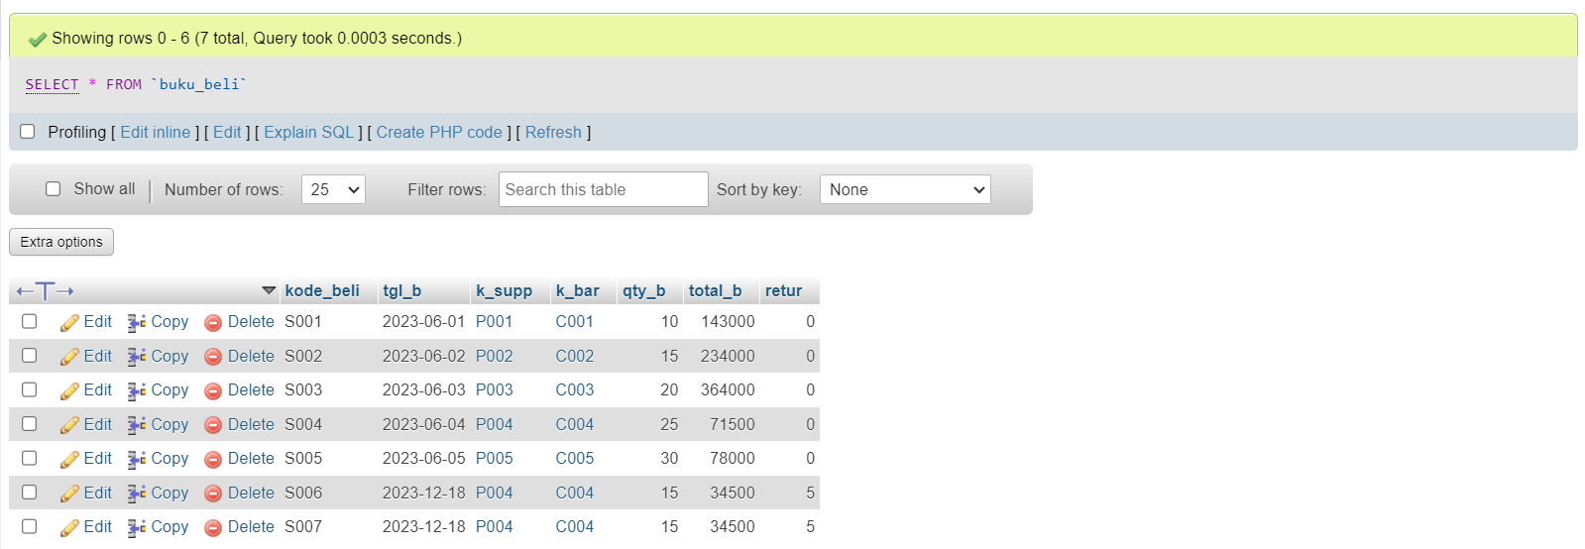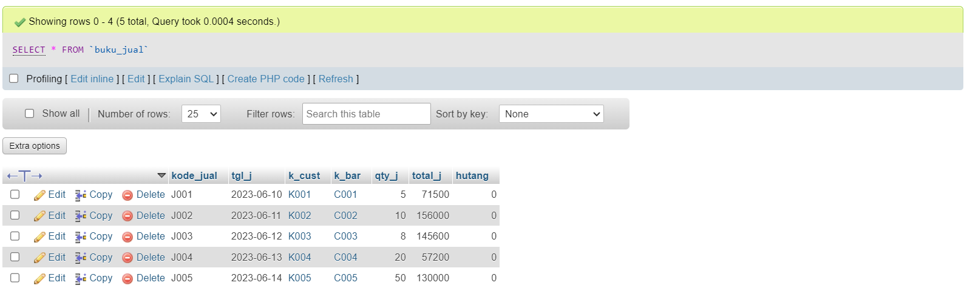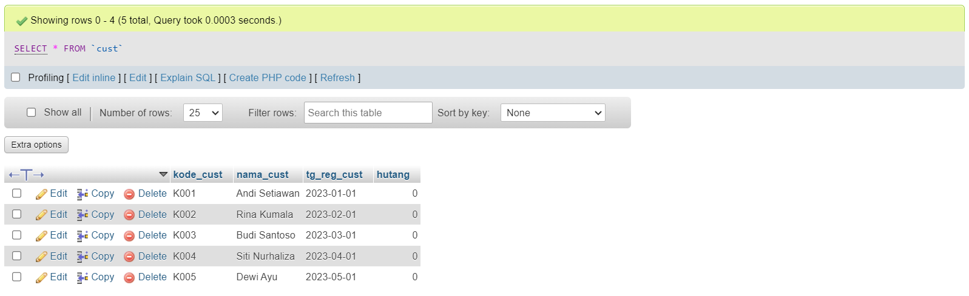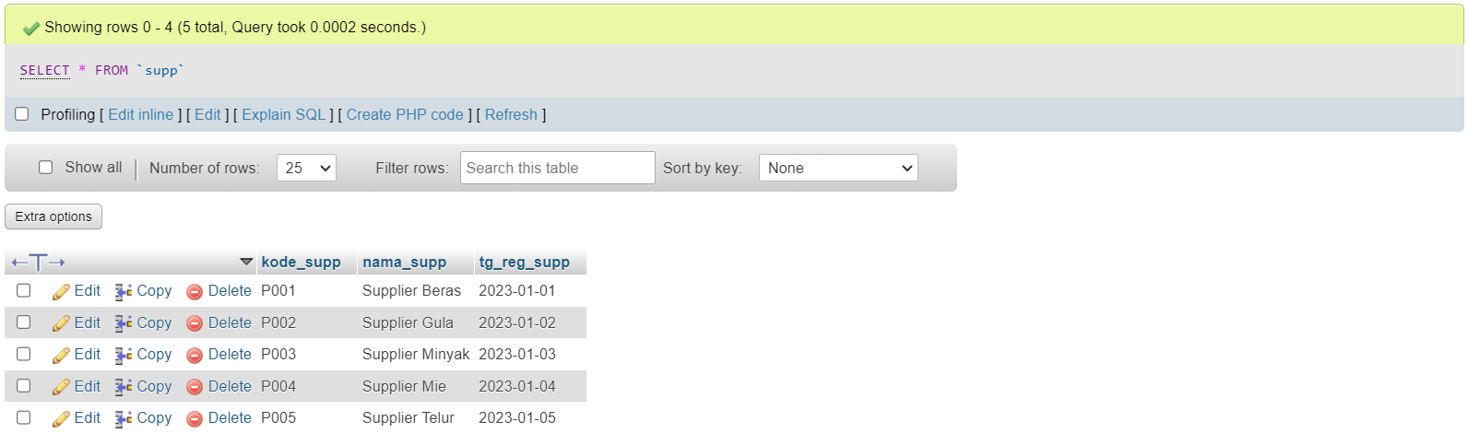

* The example of data based on the ERD model.



* The example of data based on views.

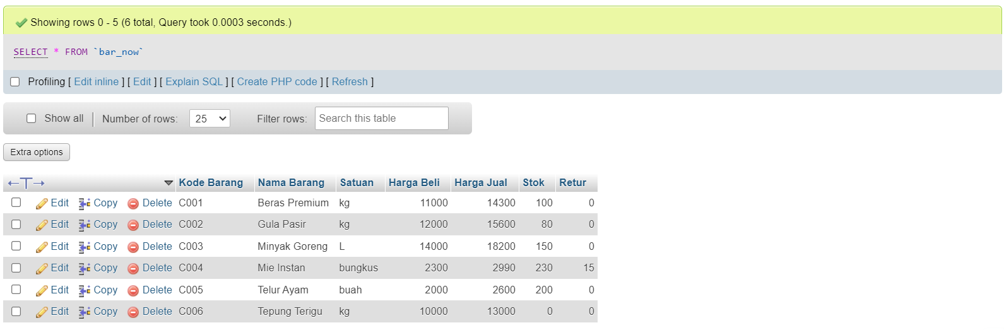

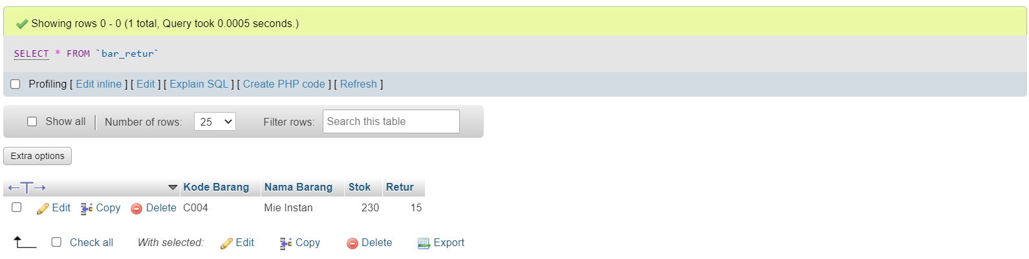

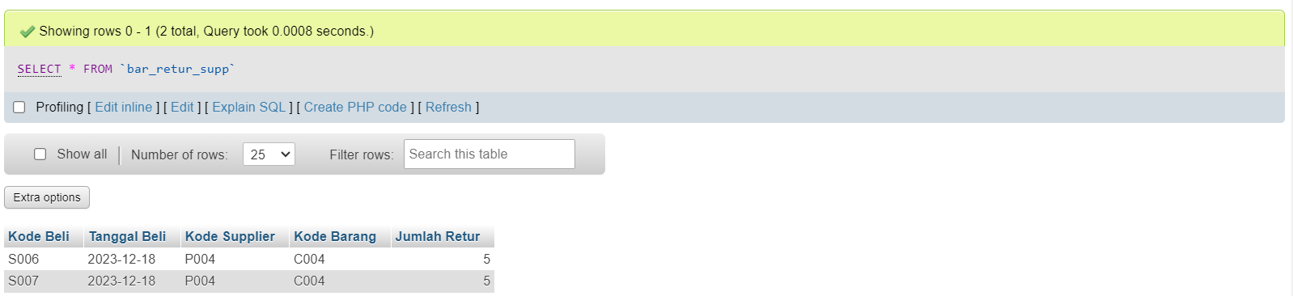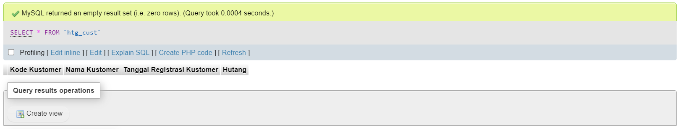

* The example of data based on stored procedures.  
  **add_new_bar()**

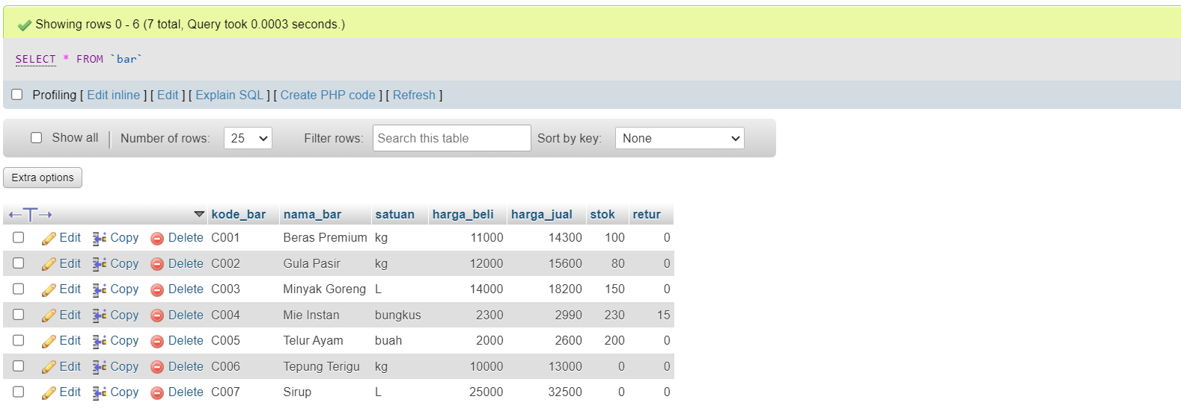

**beli_br_n_retur()**

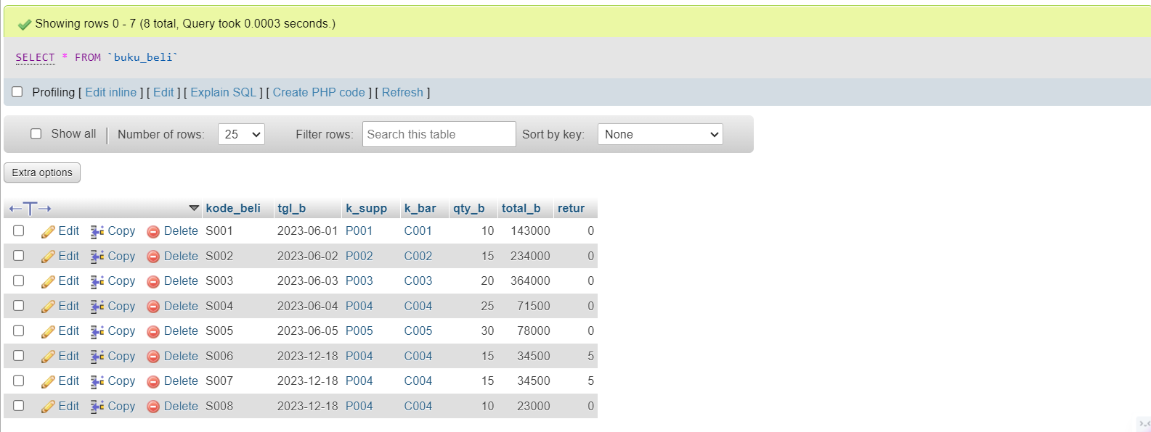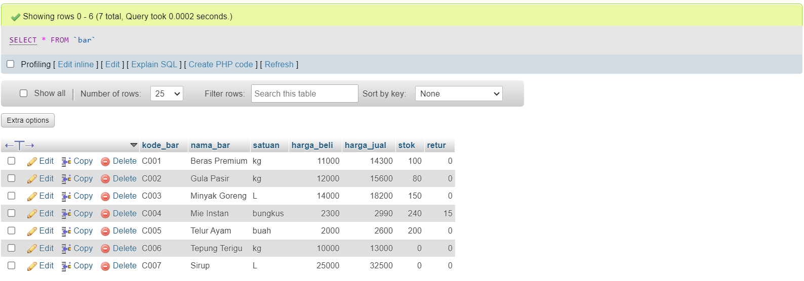

**beli_br_y_retur()**



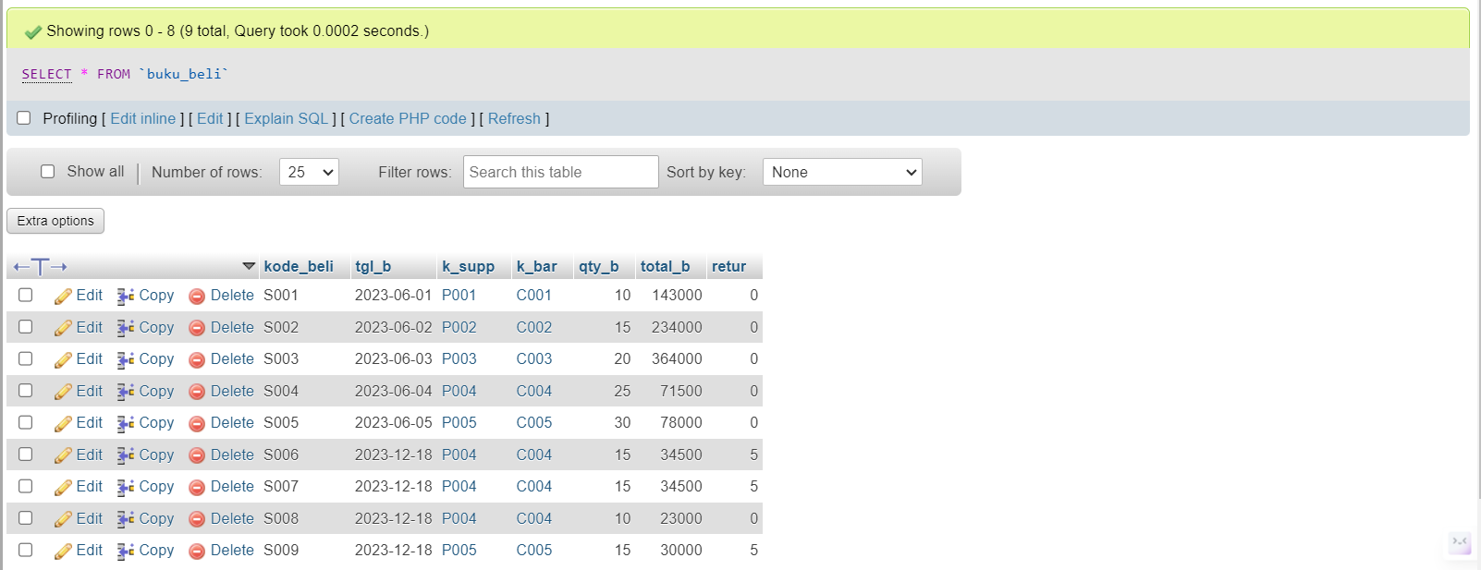

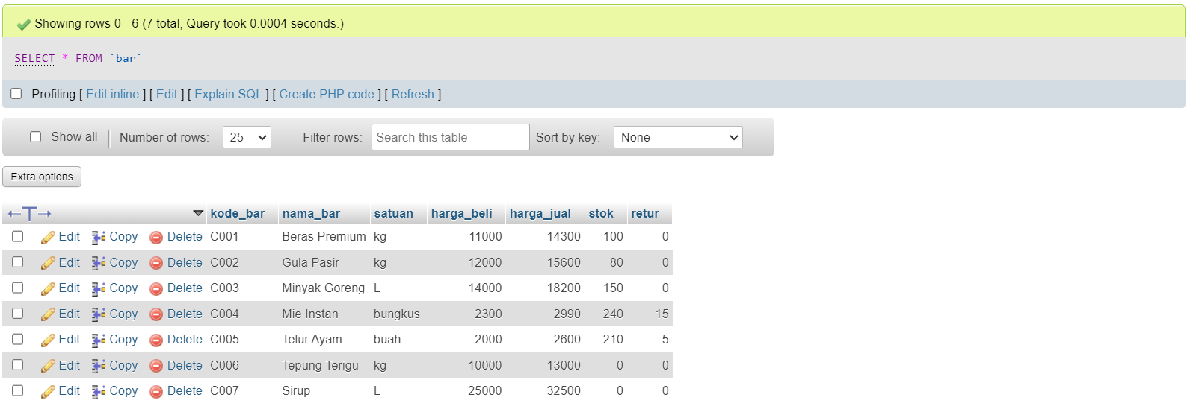

**jual_br_n_htg**



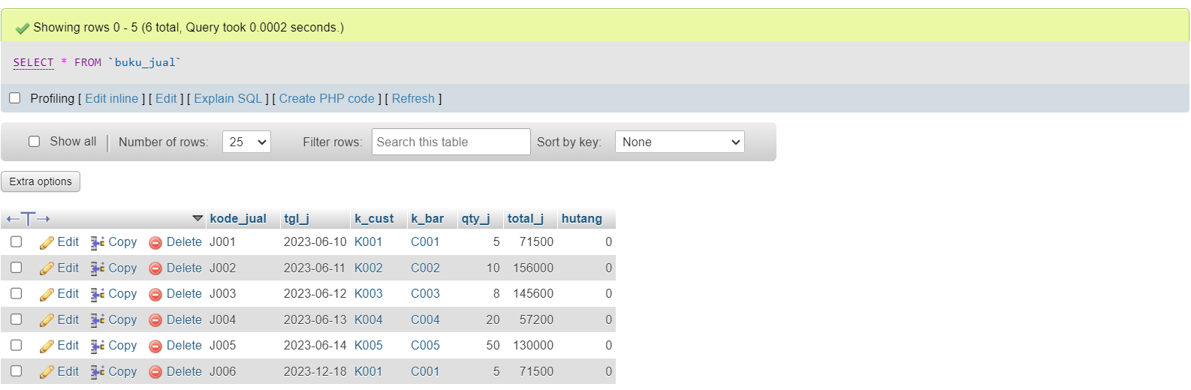

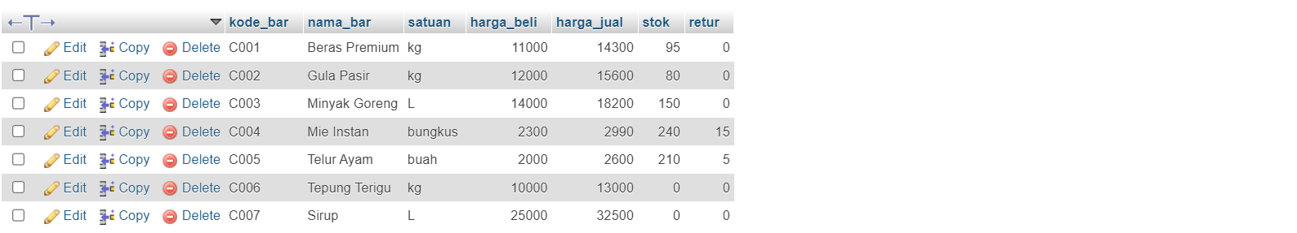

**jual_br_y_htg**

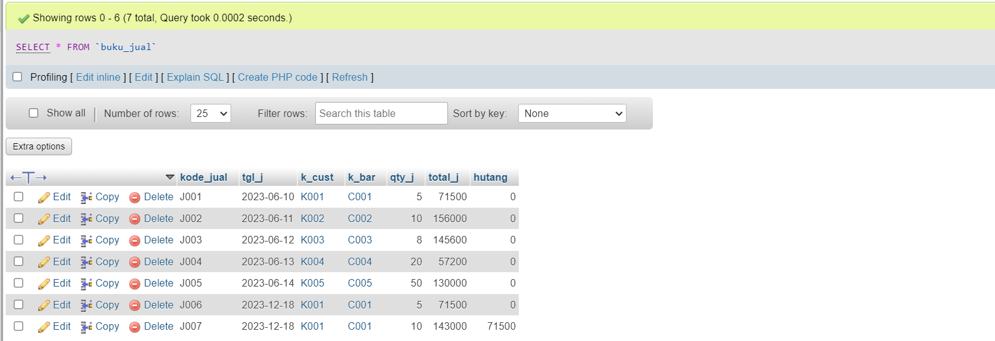

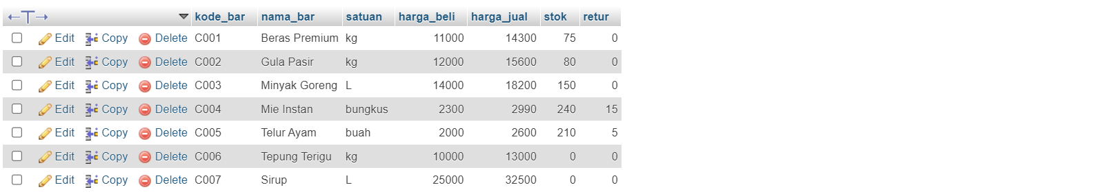

**rekap_beli_bulanan()**

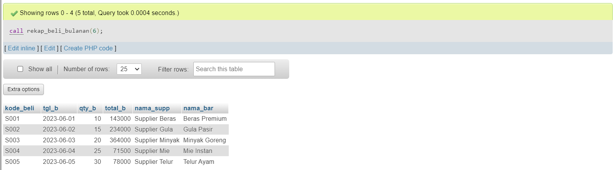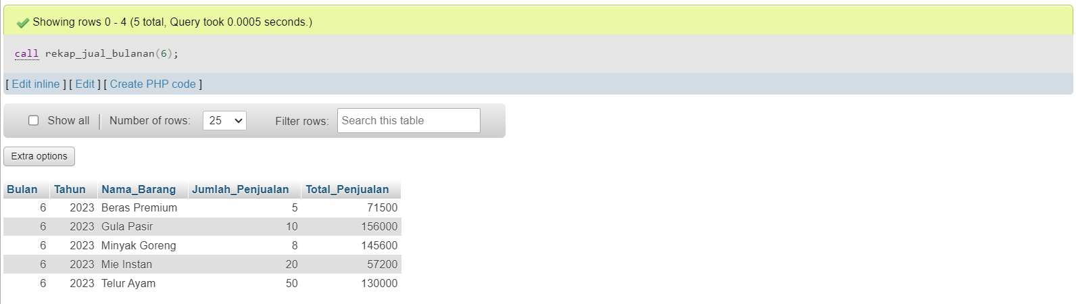

**rekap_total()**

